Point Solutions

Turning Point is now Point Solutions. The name has changed but the software has not.

What is it?
Turning Point is an interactive learning tool that seeks to engage participants in active participation through live polling. Turning Point can be used in the classroom, lecture hall, meetings and online.

Why do you use it?
Live polling has been proven to increase student attention, gives all students a voice, even those who tend to be reluctant to raise their hands. Improve class attendance and student participation. Improves instructor understanding of students’ comprehension of curriculum. Provide students with immediate feedback about the accuracy of their understanding of the curriculum. Provide instructor with instant feedback of students’ understanding of concepts and content knowledge.

How do you access it?
Turning Point participants requires a license for students to access sessions. The instructor generates a session id through the program and students connect to it through an app or web browser.
As an instructor, you will need to have the software updated/downloaded onto your computer in order to create or update interactive questions. The desktop icon has changed and looks like the following. The main lecture halls are updated with this version.

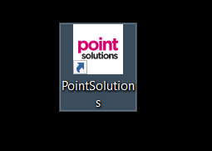

If you do not have Turning Point or Point Solutions already installed your computer, you can download the software at the following link.
https://instructor.turningtechnologies.com/downloads#/downloads

If you currently have Turning Point downloaded all you need to do is open the software and follow the steps below. Click on the version that shows at the bottom of your screen which may be different from the screen print shown below.

A pop up window will follow. Then click on Check for Updates. Run the update and proceed with the latest version.
