How to Upload Grades

First, download the template (csv file). Add grades in the template (do not make any changes to the template- keep as is) and save it onto your computer.
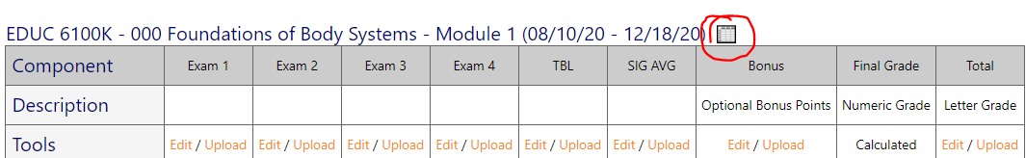

Next, click on Upload. Choose the template that you saved and upload the file.
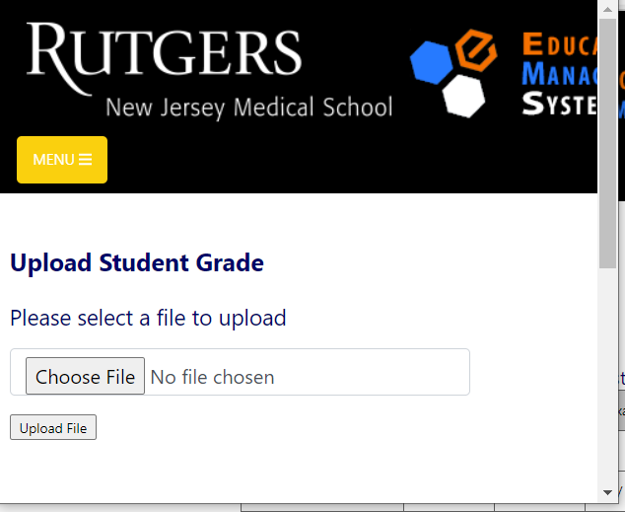

The grades will populate from the CSV file. Be sure the hit the Save button at the bottom of the page.

