How to Release Grades

Click on Edit. A dropdown box will appear with release options “Yes” and “No”.
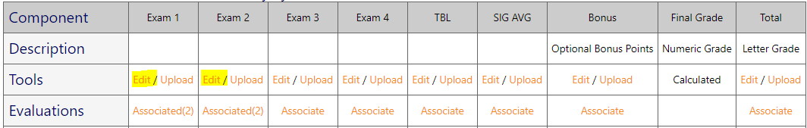

Select “Yes” if you choose to release grades for a specific column. Once “Yes” is selected, the grades are released to the students. Please keep in mind like the legacy system, a student will not be able to view the grade if he/she has not completed the associated evaluation(s).
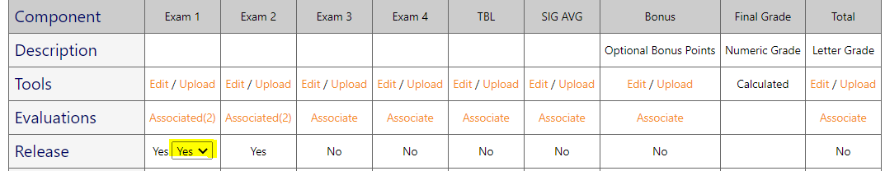

*The Edit option is also where you would enter curve and bonus grades.

