Zoom for Outlook makes it easy for you to schedule, start, and join Zoom meetings and Personal Room meetings directly from Microsoft Outlook. When it’s time to join, everyone can click the link in the calendar invitation, or they can join from a video system or phone.

Setting up ZOOM Outlook for Windows
- Open Outlook on your PC
- Select the Calendar option in the bottom left-hand corner of the screen.
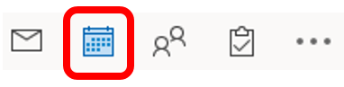
- Begin to schedule a new meeting by selecting New Meeting in the top left-hand of your screen.
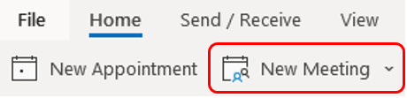
- You will now see the new meeting window. Select the Add a Zoom Meeting icon in the top right.
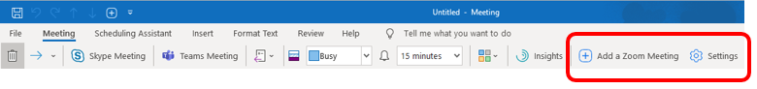
NOTE: Steps 5 through 8 are only performed the first time you schedule a Zoom meeting in Outlook.
- If the following message pops up:
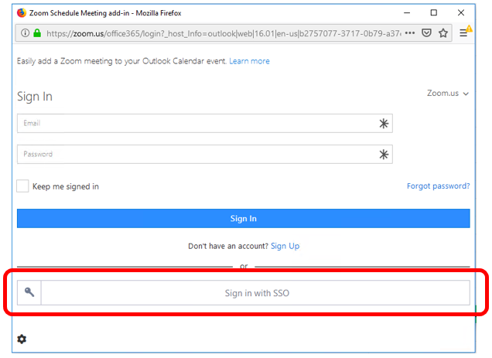
  - Click the Sign in with SSO
  - If you don’t get this message skip to step 9
- Enter rutgers in the domain field and click Continue
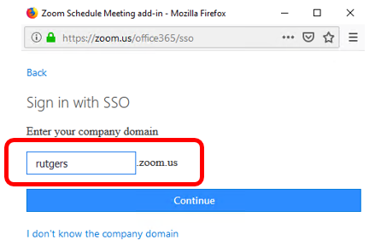
- Enter your NetID and NetID password on the Rutgers Central Authentication Service (CAS) window
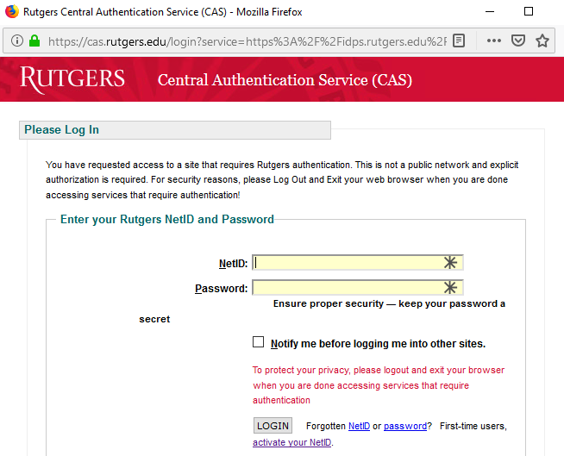
- Click Login
- You will now see that a Zoom meeting has been added to your event, and you can schedule it as you would any other Rutgers Connect calendar event. You have to view the full details of the meeting in order to view the Zoom button. It won't show up in the small window that pops up when you create a meeting. The Zoom meeting will be adjusted to match the time and date set by the calendar event. The details will be in the notes for the meeting and the title of the meeting will be taken from the title you put on the calendar appointment. If you edit the event in the future, the Zoom meeting will be updated accordingly.
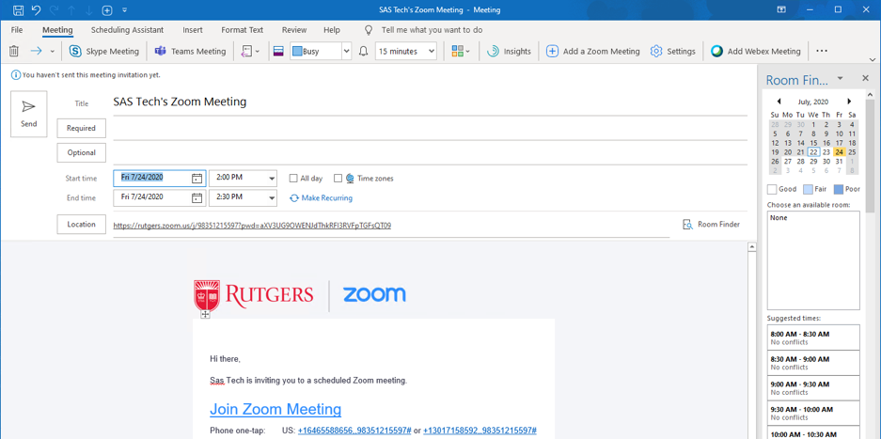

Zoom Meeting Settings
- Meeting settings can be adjusted by clicking on the Settings option.
- After the information has been added to the calendar invite, you can click on Settings under the Zoom option to change the settings for that meeting.

Setting up ZOOM Outlook for MAC
- Open Outlook on your Mac
- Select the Calendar option in the bottom left-hand corner of the screen.
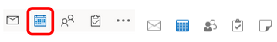
- Begin to schedule a new meeting by selecting New Meeting in the top left-hand of your screen.
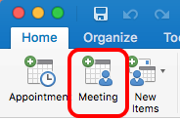
- You will now see the new meeting window. Select the Add a Zoom Meeting icon in the top right.
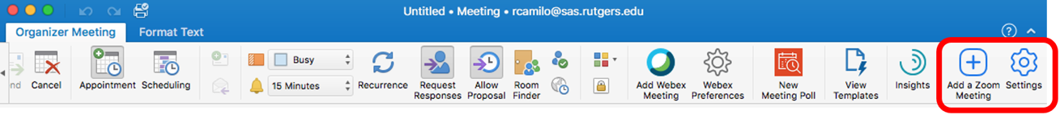
NOTE: Steps 5 through 8 are only performed the first time you schedule a Zoom meeting in Outlook.
- If the following message pops up:
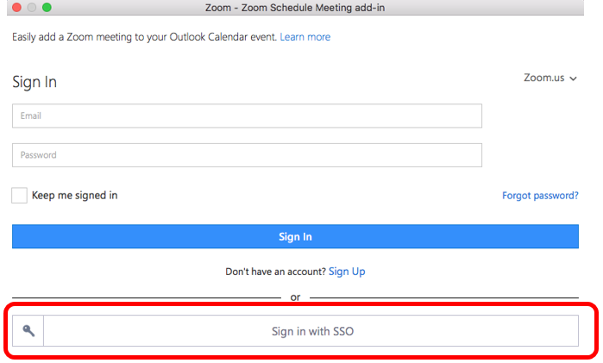
  - Click the Sign in with SSO
  - If you don’t get this message skip to step 9
- Enter rutgers in the domain field and click Continue
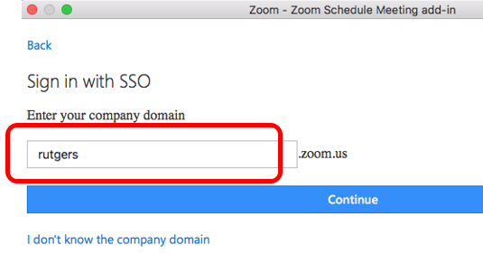
- Enter your NetID and NetID password on the Rutgers Central Authentication Service (CAS) window
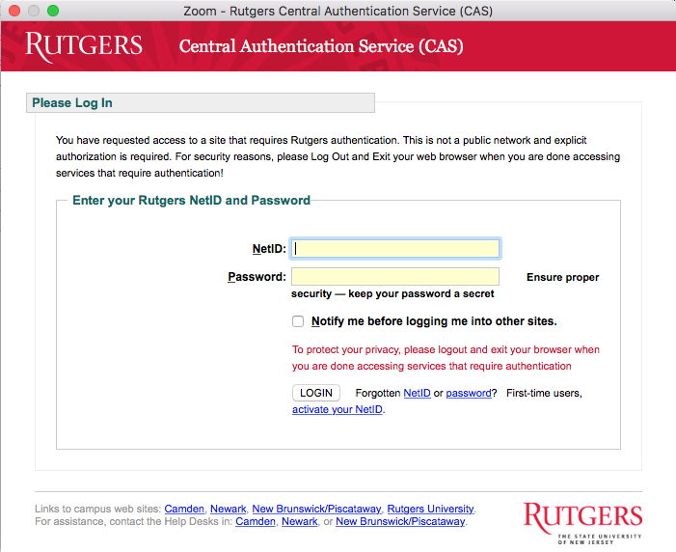
- Click Login
- You will now see that a Zoom meeting has been added to your event, and you can schedule it as you would any other Rutgers Connect calendar event. You have to view the full details of the meeting in order to view the Zoom button. It won't show up in the small window that pops up when you create a meeting. The Zoom meeting will be adjusted to match the time and date set by the calendar event. The details will be in the notes for the meeting and the title of the meeting will be taken from the title you put on the calendar appointment. If you edit the event in the future, the Zoom meeting will be updated accordingly.
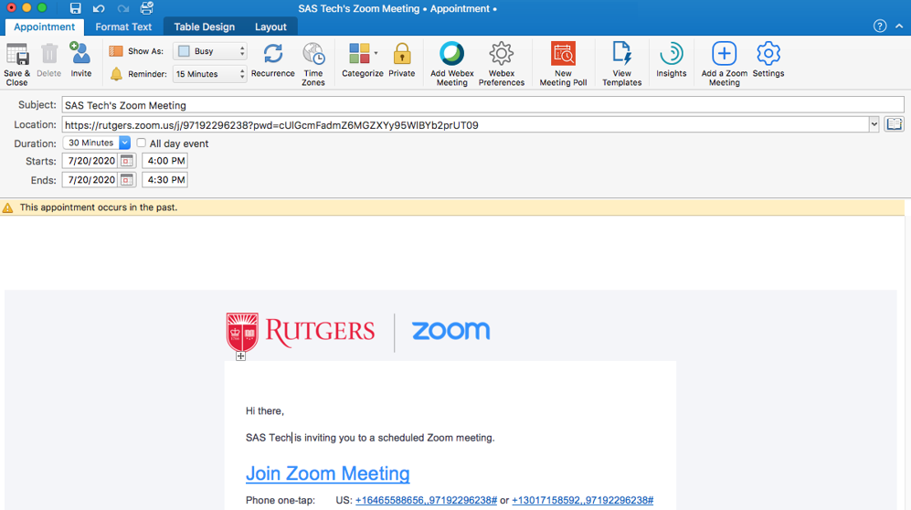

Zoom Meeting Settings
- Meeting settings can be adjusted by clicking on the Settings option.
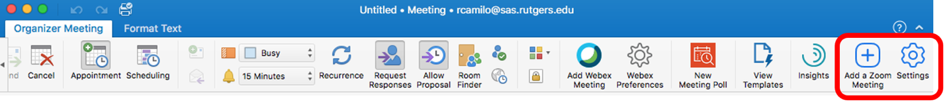
- After the information has been added to the calendar invite, you can click on Settings under the Zoom option to change the settings for that meeting.

Don’t See the Zoom Icons?
Depending on the version of Outlook you have, you may to install the plug-in. You will know if you don’t have the Zoom icons displayed in your Outlook calendar after setting up your Zoom Account.
Visit https://zoom.us/download, download and install the Plugin for Microsoft Outlook – Don’t click Add Zoom
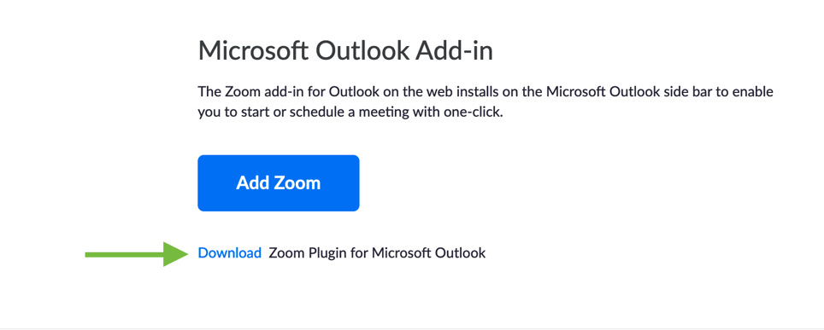
Now attempt the above instructions again.

