- Navigate to https://connect.rutgers.edu
- Select the Calendar option in the bottom left-hand corner of the screen.
- Begin to schedule a new meeting by selecting New Event in the top left-hand of your screen.
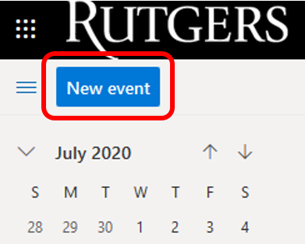
- Click on the Zoom icon. If you don’t see I, then from the top options on the New Event page, select the three dots on the right side of the top of the window, and then go to Zoom.
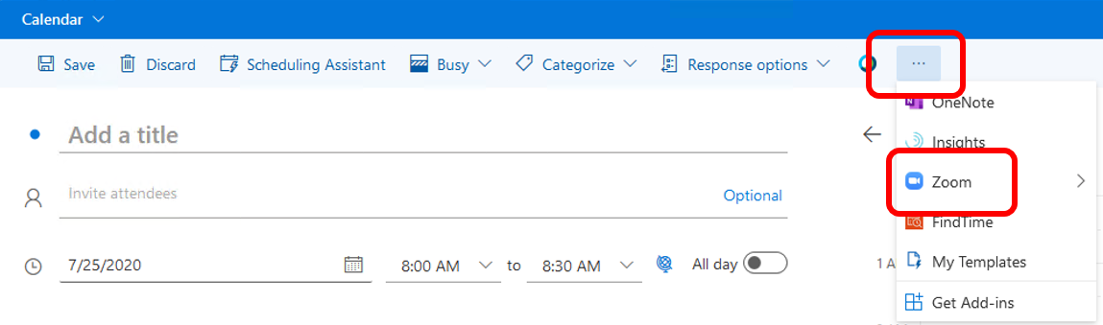
- Select Add a Zoom Meeting
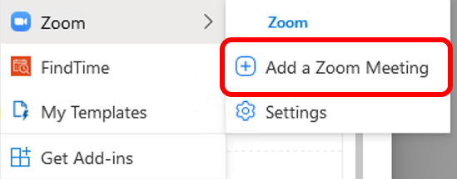

NOTE: Steps 6 through 10 are only performed the first time you schedule a Zoom meeting in Rutgers Connect.
- If the following message pops up:
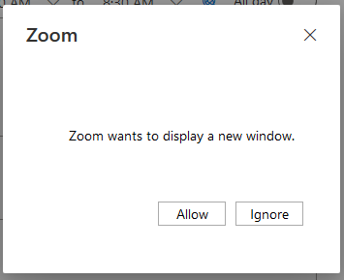
  - Click the Allow
  - If you don’t get this message skip to step 11
- Click Sign in with SSO
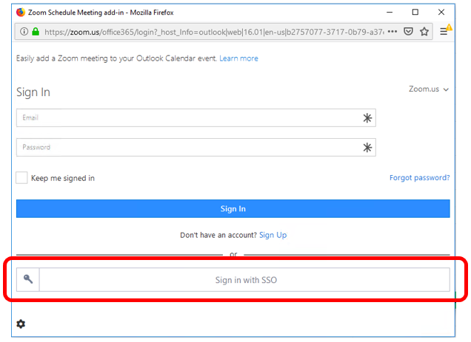
- Enter rutgers in the domain field and click Continue
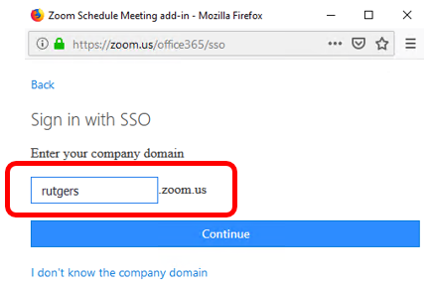
- Enter your NetID and NetID password on the Rutgers Central Authentication Service (CAS) window
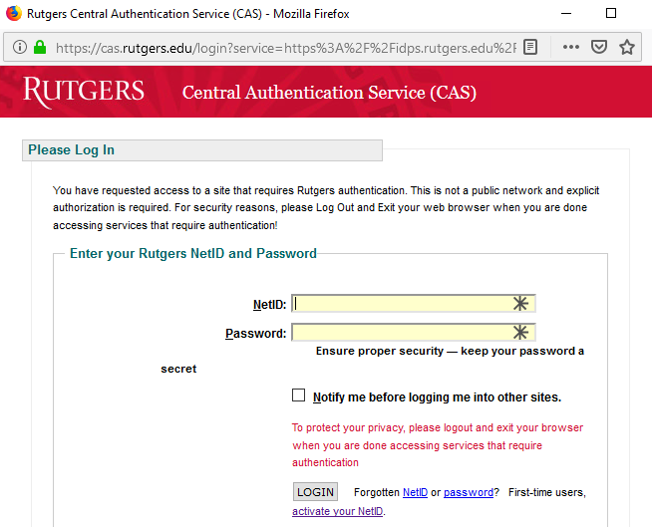
- Click Login
- You will now see that a Zoom meeting has been added to your event, and you can schedule it as you would any other Rutgers Connect calendar event. You haveto view the full details of the meeting in order to view the Zoom button. It won't show up in the small window that pops up when you create a meeting. The Zoom meeting will be adjusted to match the time and date set by the calendar event. The details will be in the notes for the meeting and the title of the meeting will be taken from the title you put on the calendar appointment. If you edit the event in the future, the Zoom meeting will be updated accordingly.
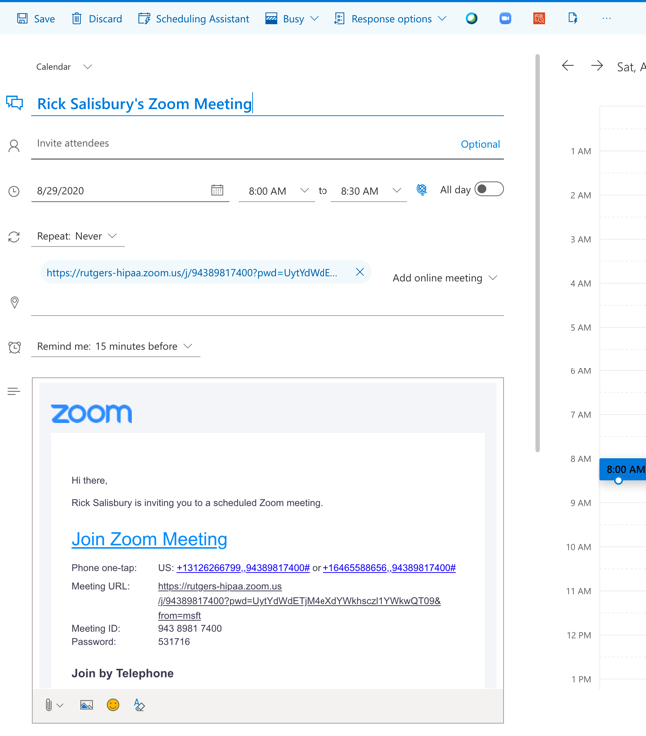

Zoom Meeting Settings
- Meeting settings can be adjusted by clicking on the Settings option.
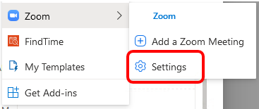
- After the information has been added to the calendar invite, you can click on Settings under the Zoom option to change the settings for that meeting.

