How to Generate Turning Point Reports

On the Turning Point toolbar, click on Reports (highlighted yellow)
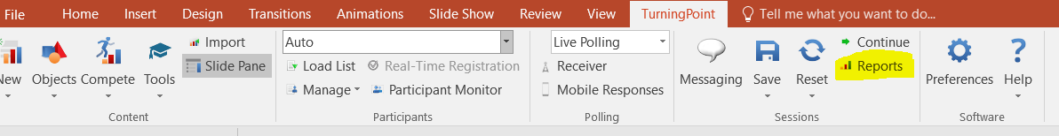

There are many report options on the upper right menu.
You can also export into a CSV, EXCEL or HTML
