- TEACHERS
- SCHOOLS
- DEVELOPERS
- BLOG
- TRY NOW!
Tutorial Videos
Welcome! This page has videos to help you quickly get started with BigBlueButton.
The BigBlueButton client runs within your web browser (no app to download and install). We recommend using the latest version of Chrome or FireFox on your desktop or laptop computers. If your using a chromebook, use the built-in Chrome browser.
The BigBlueButton client also runs on mobile devices (again, you don’t need to install any app). When using an iPad or iPhone, BigBlueButton runs within the default Safari Mobile browser (iOS 12.2+). When using an Android device, BigBlueButton runs within the default Chrome browser (Android 6.0+).
If you want to try out BigBlueButton with your desktop, laptop, chromebook, or mobile device, you can create your own personal room at https://demo.bigbluebutton.org/.

Viewer overview (student)
Watch this video if you are going to use BigBlueButton. If you are teaching with BigBlueButton, also watch the video to the right.
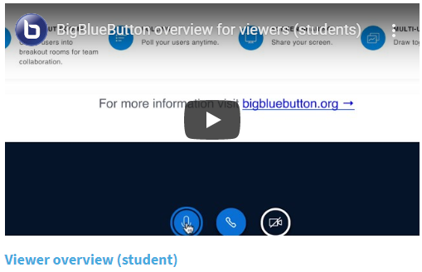

Moderators/presenter overview (instructor)
Watch this video if you are going to present or teach with BigBlueButton.
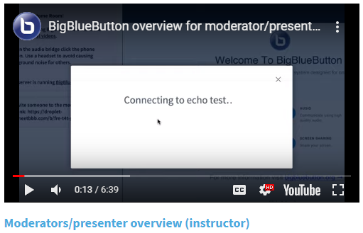
Pan and Zoom
A look at the support for Pan and Zoom in the HTML5 client.
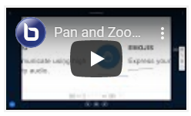
Shared Notes
Collaborating with your peers on a single set of notes for the session.
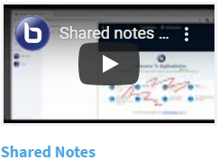

Shared YouTube Video
Presenters can share YouTube video’s and synchronized playback to all users.
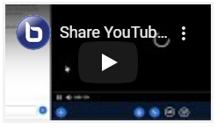
Live Closed Captions
A stenographer can now enter live captions. The product supports live captions in multiple languages.
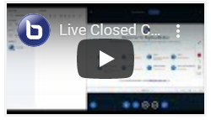
BigBlueButton
- Home
- For Teachers
- For Schools
- Accessibility
- Blog
- Demo
Open Source Project
- About
- License
- Trademark
- Privacy
Developers
- Install
- Documentation
- Contribute
- Developer Group
- Integrations
Support
- Tutorial Videos
- FAQ
- Community Support
- Commercial Support

© 2020 BigBlueButton.

